**Langchain and MCP**

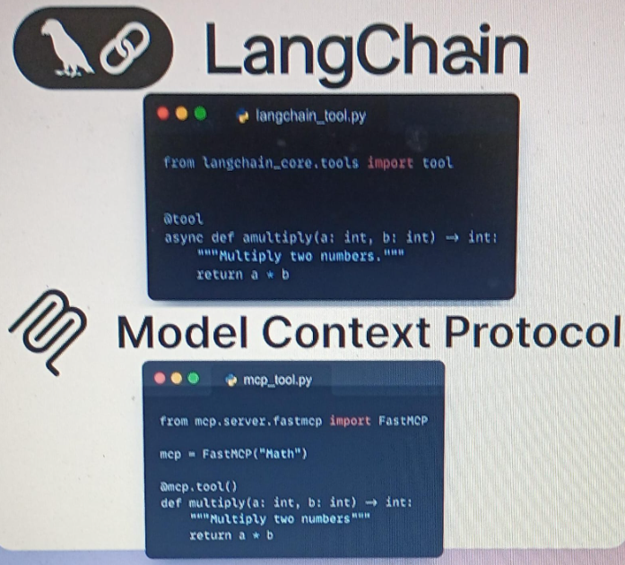

Both MCP and langchain use external tools which are simple function which execute and have argument and return value. We need to specify when should we call this function, so this is going to be described in the functions' description. So, the description is very, very important, because this is eventually going to propagate to the LLM, whether by the LangChain biding tools or by the MCP client, and this is going to help the model decide which tool to call. So, MCP and langchain tools are this very similar.

Differences (between Langchain and MCP):

Along with exposing tools via MCP, it also exposes resources like documents, PDF files, pictures, making API calls, prompts.

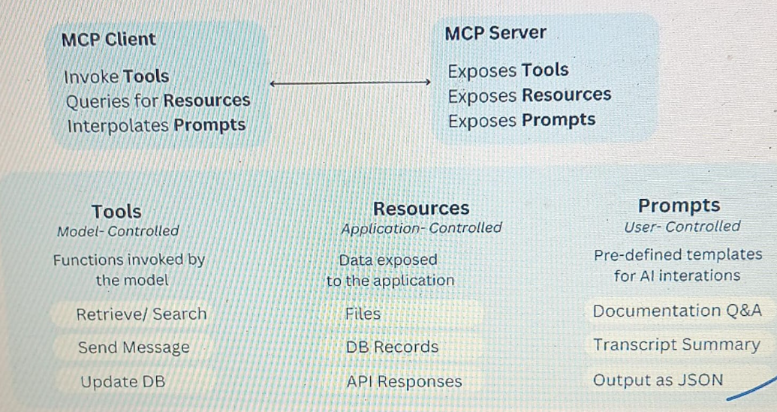

And another difference is who we are going to expose this to. So in LangChain, when we use the bind_tools, we bind it to an LLM. But when we use MCP, we actually bind everything to the AI application, like Cursor, Windsurf, Claude. So those applications have underneath the hood an LLM, and the client is what is going to inject those descriptions to that LLM. So we're not injecting it directly. We have a couple of layers of extractions before it's getting injected, so we have the MCP server, which communicates with the list of tools to the MCP client and the MCP client is what's going to inject the LLM in the application with those instructions of the tools that we need to invoke.

**MCP Adapter:**

https://github.com/langchain-ai/langchain-mcp-adapters

This is an open-source that the LangChain team released, which offers significant value by enabling seamless integration of MCP tools with LangChain and LangGraph. So the key value here is that we have tool compatibility. So we can convert MCP tools into LangChain and LangGraph agents compatible tools. So this allows developers to leverage existing MCP servers that somebody else wrote without any manual adaption.

And it also supplies us with an MCP client that will allow us to connect to multiple MCP servers, which is going to help us expose all their tools.